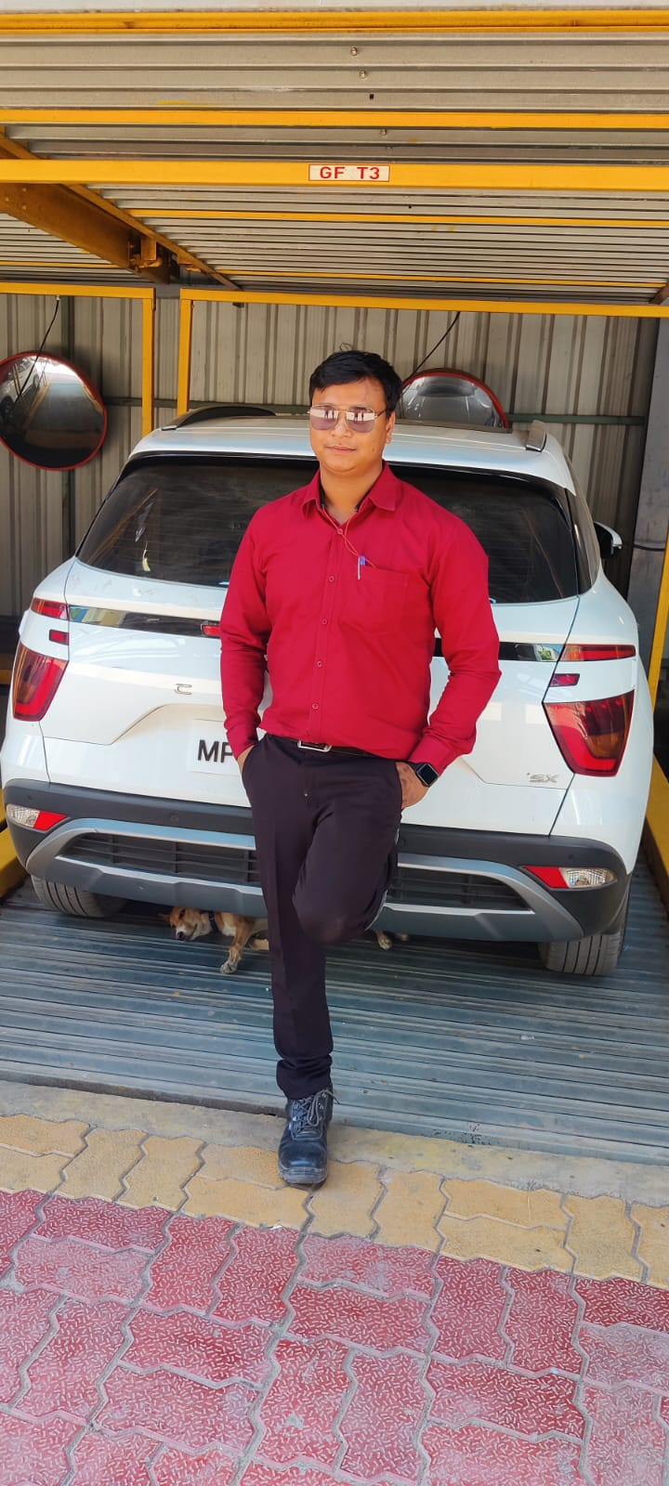

**Name: Mr Rahul Kumar Singh**

**CV for the Post of Senior Technician in RR Parkon, Jabalpur Division**

**Experience**

* **2020-2023**

RR Parkon | Civic Centre, Jabalpur

Technician of Multilevel Car Parking System

* 2019-2020

RR Parkon | Civic Centre, Jabalpur

Operator of Multilevel Car Parking Modules

* 2017-2019

VD Engineering| Aadhartal Jabalpur

Fitter of Petrol Tank Manufacturing Unit

**Key Achievements/ Extra Curriculum**

Participated in Cycling Tour for save patrol initiative organized by Nagar Nigam Jabalpur

**Reference**

1. **Anup Kumar Singh**

Civil Contractor IOCL

Mob : 9560016371

Address: Pragati Nagar, Tilhari, Old Mandla Road, Jabalpur, M.P, Pin: 482020

1. **Mani Kumar Singh**

Ex-Serviceman (Army)

Mob: 9617966566

Address: Pragati Nagar, Tilhari, Old Mandla Road, Jabalpur, M.P, Pin: 482020

**Contact**

**Phone**

9031288235

**Email**

rahulsingh6500@gmail.com

**Address**

Pragati Nagar, Old Mandla Road, Bilhari, Jabalpur, M.P PIN: 482001

**Education**

2015

ITI (Fitter)

2015

BA (History)

Bihar University

2012

Intermediate (12th) with PCM

Bihar University

2010

Highschool (10th)

Bihar University

**Expertise**

Electrical Works

Mechanical Works

Arts & Craft

**Curriculum Vitae (CV)**